**HTML Exercise: Create Your Own Portfolio Website**

**Objective**

To design and develop a personal portfolio webpage using HTML, showcasing personal details, skills, projects, and academic qualifications.

**Problem Statement**

You are required to create a **portfolio website** that contains the following sections:

1. **Header** with your name and navigation links (About, Projects, Skills, Education, Contact).
2. **About Section** with a short introduction and contact details.
3. **Projects Section** listing at least two projects in a table or list format.
4. **Skills Section** using a simple list.
5. **Education Section** with a table (S. No., Class/Degree, Board/University, Marks, Division).
6. **Contact Section** with a simple form (Name, Email, Message, Submit button).

**Theory Recap**

Students will practice:

* **Basic HTML structure**: <!DOCTYPE html>, <html>, <head>, <body>
* **Navigation links**: <a href="#section">
* **Tables**: <table>, <tr>, <th>, <td>
* **Lists**: <ul>, <li>
* **Forms**: <form>, <input>, <textarea>
* **Sections & headings**: <header>, <section>, <h1>–<h3>

**Procedure / Steps**

1. Create a new file portfolio.html.
2. Add the HTML boilerplate (<!DOCTYPE html>, <html>, <head>, <title>).
3. Inside <body>, create sections for Header, About, Projects, Skills, Education, Contact.
4. Add navigation links at the top that jump to each section using href="#id".
5. Use a table to display **Education details**.
6. Use a list for **Skills**.
7. Add a form in **Contact** section.
8. Save and open in a browser.

**Register Yourself for Github Classroom:**

**LINK:** **<http://bit.ly/47zr5DN>**

**(Scan QR code below)**



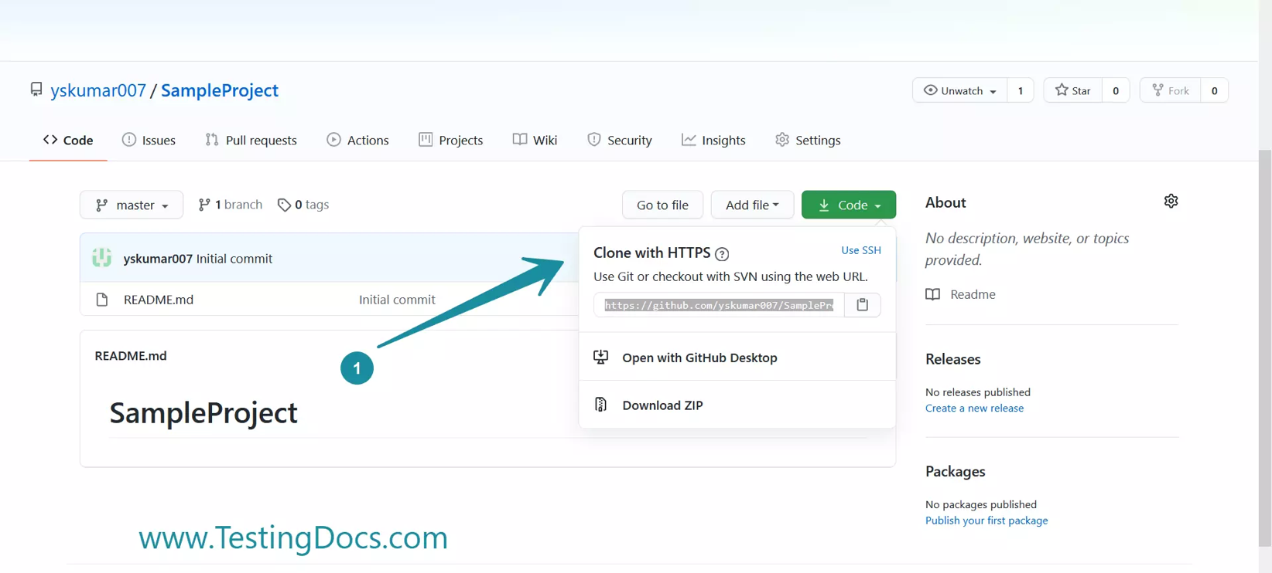

**HTML Exercise: Create a Student Registration Form**

**Objective**

To design an HTML form for student registration using different form elements.

**Problem Statement**

Design a registration form that collects the following details from the student:

* Full Name
* Email
* Password & Confirm Password
* Gender (Radio Buttons)
* Hobbies (Checkboxes)
* Course Selection (Dropdown)
* Address (Textarea)
* Submit & Reset Buttons